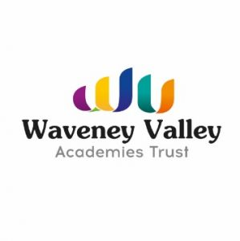
WVAT Covid-19 Statement
In line with the recent publication of the government’s roadmap setting out the next steps in terms of dealing with the Covid-19 emergency, Waveney Valley Academies Trust have worked closely with our school leaders to build an approach to further facilitate the opening of our schools.
We have created our own roadmap which outlines the order in which wider opening will be undertaken. We believe that our own approach is in line with that of central government, with a focus on monitoring and review to assess any increased risk as children are gradually reintroduced to a school environment, albeit one with a very different feel to the school they left back in March.
The Trust will ensure that all appropriate resources are available to schools, and that appropriate safety measures are implemented, in line with government advice. As a Trust, we pride ourselves on collaborative working and therefore have an expectation that every staff member, parent and young person will continue to support and work with our school leaders as we welcome young people back to the classrooms. Obviously it is essential that the new, covid-secure practices, which have been put in place under government guidelines for everybody’s safety, are followed. The Trust will support school leader’s decisions around proportionate responses and/or action where students / pupils fail to follow these guidelines.
In conclusion, we would like to express our thanks and our gratitude for the work our staff have undertaken so far in these unprecedented times, and for their ongoing collective efforts over the next few weeks and months.

